The Destruction of America – the Modern Day Nineveh
June 24, 2016
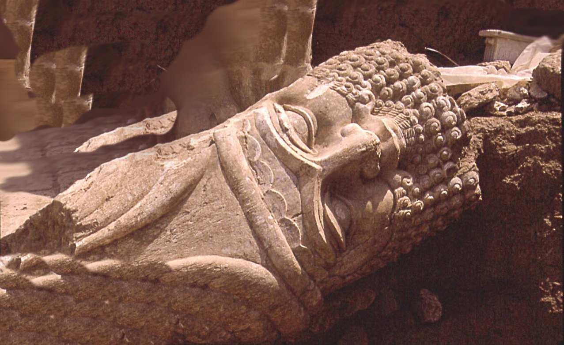
The Steadfast Endurance of Jesus in His Passion be with you all.

Please, Heartdwellers, pray the Divine Mercy prayer every day. The three o’clock hour is best if you can, but please pray it. And avail yourselves to the Stations of the Cross, which will greatly strengthen you in adversity.

Tonight, when I had a communion service, I held up the wine to the Lord and, as on other nights, I saw Him take the chalice and pour it over the Earth. I also saw Him break the host over the Earth. He is pouring Himself over the Earth, Heartdwellers…for those last minute conversions and in atonement for our sins and the sins of the whole world.

So, when I came into prayer, the Lord was holding me very closely. His mood was pensive…

"Oh, Clare, we are so very close. So close, I am breathless. This is much more intense than My Passion, much more."

And as He held me, I just sensed the groaning coming up from His bowels. Just a terrible groaning - deep, deep, deep interior aching coming up from inside of Him.

He continued, "Up until now, I have not allowed you to see My status. But I must tell you, I am in excruciating pain. I am truly breathless. This is the worst thing that I have ever had to do. There is no parallel. But the Earth must be cleansed of the filth that has overtaken it.

"So much harm has been done by the greedy and rich. They are literally eating the food off the plates of the poor; whereas I created the Earth rich in resources for all. Poverty was never necessary, although I have used famines to get the attention of My People when they went astray.

"But now, what can I say? 'Father deliver Me from this hour, but not My will but Thy will be done.' This must be done, but how overwhelmingly sinister and dark are the days ahead. My Bride, I have not wanted to sully our wedding day with these concerns, but how can I hide them from you? You know I have not been transparent with you. And it is not My Heart nor My custom to keep things hidden from My very own flesh and blood.

"Oh, My heart stands still and there is silence in Heaven for what must soon come to pass. All are astonished and holding their breath for the destruction of the nations. All are intensely tuned in to this hour upon us. We are in complete and extraordinary unity…and all are holding their breath, just as I am.

"The Earth itself waits with all Creation groaning, over what must come to pass. The universal awareness of the struggle between light and darkness is amplified thousands of times in the very being of My Creation. Oh, yes, My Creation has being, though it is not in My likeness; nonetheless, it has awareness of those things necessary to it.

"And like a horse being ridden by a drunkard, it is acutely aware of the corruption of mankind. Yes, acutely aware. It is the hour of blackness…the triumph of evil over good."

And at that point, Heartdwellers, I needed to take a break. I felt like the Lord wanted to speak to me through the Scriptures. So, I prayerfully opened the Bible to the Book of Nahum, which is all about the destruction of Nineveh, and how the cruelty of the Assyrians in Nineveh was felt by other nations. It was destroyed by fire and water.

I want to take a moment and share with you some of the parallels.

“After having ruled for more than 600 years with hideous tyranny and violence, from the Caucasus and the Caspian, to the Persian Gulf and from beyond - the Tigris to Asia Minor in Egypt, Nineveh vanished like a dream. Its end was strange, sudden, tragic. It was God's doing, His judgment on Assyria's pride. The appearance of the ruins shows that the destruction of the city was due not only to the assailing foe, but also to the flood and fire. Thus confirming the ancient prophecies concerning it. The recent excavations have shown that fire was a great instrument in the destruction of the Nineveh palaces. Charred alabaster, charred wood and charcoal, colossal states split through with heat are met with in parts of the Nineveh mounds, and attest to the veracity of prophecy.” (Biblical foreword comments.)

So, this was ancient Nineveh. And the Lord here is using this as a parallel to current day Nineveh. There are highlights here that are just striking parallels with the United States.
(in the following, Clare’s reflections are in parenthesis.)

1:2 The Lord is a jealous and avenging God;
the Lord takes vengeance and is filled with wrath.
The Lord takes vengeance on his foes
and vents his wrath against his enemies.
3 The Lord is slow to anger but great in power;
the Lord will not leave the guilty unpunished.
His way is in the whirlwind and the storm,
and clouds are the dust of his feet.
…5 The mountains quake before him
and the hills melt away.
The earth trembles at his presence,
(Earthquakes and tsunamis)

the world and all who live in it.
6 Who can withstand his indignation?
Who can endure his fierce anger?
His wrath is poured out like fire;
the rocks are shattered before him.
(And that sounds very much like nuclear war to me.)

7 The Lord is good,
a refuge in times of trouble.
He cares for those who trust in him,
(Especially those of us who are praying Psalm 91 and really do trust in the Lord.)

8 but with an overwhelming flood
he will make an end of Nineveh;
he will pursue his foes into the realm of darkness.
(And this reminded me of NYC under water, the overwhelming flood. New York and San Francisco.)

...and pursue his foes into the realm of darkness.
(The multi-level D.U.M.B.S. underground bunkers and bases, the realms of darkness. Whatever they plot against the Lord, the New World Order here)

he will bring to an end;
(and that reminds me of the Millennium.)

trouble will not come a second time.
10 They will be entangled among thorns
and drunk from their wine;
they will be consumed like dry stubble.
(And that reminds me of the materialism that's so heavy in this country, that people do not recognize what they're in for. They're totally grown over by thorns, and they're not seeing what's coming.)

11 From you, Nineveh, has one come forth
who plots evil against the Lord
and devises wicked plans.
(That would be Obama.)

12 This is what the Lord says:
“Although they have allies and are numerous,
they will be destroyed and pass away.
(And that would be NATO, the Allies. And they will be destroyed and pass away in world war.)

Although I have afflicted you, Judah,
I will afflict you no more.
13 Now I will break their yoke from your neck
and tear your shackles away.”
(How much opposition have we given Israel in trying to divide the nation? The Lord's going to break that away.)

14 The Lord has given a command concerning you, Nineveh:
“You will have no descendants to bear your name.
I will destroy the images and idols
that are in the temple of your gods.
(That's reminiscent of the capitol rotunda and Washington, the way Washington is laid out and the intense pictographs and paintings of Roman gods.)

I will prepare your grave,
for you are vile.”
(Again, earthquakes and tsunamis.)

2:1 An attacker advances against you...
(Russia. North Korea and the Chinese.)

Guard the fortress,
watch the road,
brace yourselves,
marshal all your strength!
3 The shields of the soldiers are red;
(That's Russia.)

the warriors are clad in scarlet.
The metal on the chariots flashes
on the day they are made ready;
4 The chariots storm through the streets,
(That's Urban Warfare.)

rushing back and forth through the squares.
They look like flaming torches;
they dart about like lightning.
5 Nineveh summons her picked troops,
yet they stumble on their way.
(They're not prepared! And we hardly have any troops left, they've all been deployed to far away from our country. Deliberately.)

They dash to the city wall;
the protective shield is put in place.
6 The river gates are thrown open
and the palace collapses.
(Flooding, everywhere.)

Nineveh is like a pool
whose water is draining away.
“Stop! Stop!” they cry,
but no one turns back.
(That reminds me of after a tsunami. When a tsunami comes in, it destroys everything. And then it drains all the way back out to sea again. All her treasures are gone. New York. San Francisco. L.A. Chicago. But no-one turns back.)

9 Plunder the silver!
Plunder the gold!
The supply is endless,
the wealth from all its treasures!
10 She is pillaged, plundered, stripped!
Hearts melt, knees give way,
bodies tremble, every face grows pale.
(The shock of Americans when our country is attacked.)

3:1 Woe to the city of blood,
full of lies,
full of plunder,
never without victims!
(To me, that's Washington. Washington and New York.)

...Many casualties,
piles of dead,
bodies without number,
people stumbling over the corpses—
4 all because of the wanton lust of a prostitute,
alluring, the mistress of sorceries,
who enslaved nations by her prostitution
and peoples by her witchcraft.
(And to me, this speaks of the whole Vatican debacle, and the USA and the New World Order. Everything moving in that direction. Which, the occult symbolism beneath all of that is tremendous.)

“I am against you,” declares the Lord Almighty.
“I will lift your skirts over your face.
I will show the nations your nakedness
(Total, total destruction.)

6 I will pelt you with filth,
I will treat you with contempt
and make you a spectacle.
(Ruins everywhere and cities gone.)

11 You too will become drunk;
you will go into hiding
and seek refuge from the enemy.
12 All your fortresses are like fig trees
with their first ripe fruit;
when they are shaken,
the figs fall into the mouth of the eater.
(To me, that's the plunder of the underground cities and the D.U.M.B. bases.)

13 Look at your troops—
they are all weaklings.
The gates of your land
are wide open to your enemies;
(We HAVE no gates. We have no walls. We are un-walled villages.)
fire has consumed the bars of your gates.
(To me, that speaks of nuclear bombs.)

And I really don't want to talk anymore about it, that's certainly enough. Although, the last paragraph is very important to me, I believe.

19 ...All who hear the news about you
clap their hands at your fall,
for who has not felt
your endless cruelty?
(And that, to me, is reminiscent of the School of the Americas.)

So, there's some parallels. I've never understood what this book meant before, but I really feel the Lord opened my eyes to it, my understanding to it tonight.

And I asked the Lord about Putin, too, tonight, because I had a tremendous burden for him. And I just sense that there's something good about the man. And I was asking the Lord, 'cause the Lord told me that he was complicate in all of this. He's part of the program, that everything is scripted by the "power that be".

And I said, "Lord, please, I am troubled by what has been said about Putin. Is he really with the Elite after all?"

And the Lord answered me, "He is only complying with what must be done. He, in fact, does not have control of the world, neither do the Chinese; they are all scripted, Clare. He is a decent man, much like another leader that you admired was a decent man, but under the control of principalities. Does this put your heart at ease?"

"Yes, I guess so, Lord." He's speaking of another leader here, who was put in a position. Had a tremendous amount of integrity and loyalty to God, but he was put in a position where he couldn't act independently. But nonetheless, the Lord anointed his life, even though he had to do the things that he wouldn't have chosen to do. The Lord turned it around and He anointed him, so that what was meant for evil, turned out to be good. And I'm not going to go into that any deeper.

Then the Lord continued, and He said, "My Daughter, I am truly watching over the words of your mouth. You cannot hope to be perfect, but I can. Rest in this. I am watching over our flock and what they receive."

'Cause that was a point I was beginning to doubt: did I not hear the Lord? Did I miss Him?

And I told Him, "Thank you Lord, that really helps." And I do have a peace about this. I believe he is a good man, but he can't act independently. And he certainly right now is being forced into a stranglehold that his very survival depends on his reaction, because Obama is...wants war. He's trying to destroy our country. And the way he's going to do it is through nuclear war. But pray for Putin, because who knows what the Lord will do.

The Lord continued, "How can I speak? My tongue cleaves to the roof of My mouth in anticipation of what mankind will suffer. I can barely speak, so horrendous is the reality of the hour that is upon us.

"Prayers are being offered up as thick clouds of incense, rising to My Father’s throne all over the Earth, because My people know what is coming. Arrangements are being made by My angels to lessen the judgments in some areas because of these prayers. New York is one of them, although they do not realize the heights of evil in this city. (that is, the New Yorkers.) This city is likened to the throne of Satan in the evil that it's done. While the fate of the city will not be changed, the fate of its individuals will. There will be protection and provision extended to certain ones.

"Others have made themselves a fragrant offering for the unsaved."

Those are the ones who have said, "Lord, is I must die in this, take my life and apply some graces to those who are unsaved. Let me make an offering of my life to You for the unsaved.

He continued, "There are miracles of grace and hearts the size of a great canyon interceding right now. My Father will have great pity on many.

"In this, hour My Children, I cannot stress the importance of prayer enough. If you do not have a burden, you need only to ask. Begin praying in tongues, and whoever comes to mind, offer up your prayers for them and the burden will be gently placed in your heart. Follow up on it. Be responsive to My Spirit. All during the day and night, remember. Remember these people in your prayers. Great wonders of mercy will take place because of your tender hearts and your vigilant prayers.

"There are thrones in store for My faithful Prayer Warriors. They have no desire for such things, and that is precisely what qualifies them. Yes, thrones are prepared and from these thrones you will administer justice and assistance to the down-trodden and oppressed. Your response to humanity is what will qualify you to rule and reign - not that you care in this moment. But know that, in that moment, you will be overjoyed at the power given you to change evil to good by the assistance of My angels assigned to you.

"For the rest of you who have not received burdens as yet, ask and they shall be given.

"I leave you now with these words of encouragement. Many that will perish knew that they would from their conception and agreed to it for the sake of others. In Heaven, so many things are clearly understood. Spiritual realities are well understood, even by those souls just created from the substance of My Father’s heart.

"They well understood their offering before they came to Earth. Others who have chosen the paths of the world and repeatedly rejected Me, have chosen their eternity as well. Pray for a millisecond of repentance in that hour, that I might have an excuse to fetch them from the claws of Satan.

"You are about to entire into a horrific war zone, My People. Please be prepared to sustain your prayers for the world. And above all, cleave to Me. Cleave to Me with all your might. I am with you, even in the darkest of hours.

"I am there with you. Cleave to Me."

